Title of Abstract in 14 pt Times

A. B. Author,^{1,*} C. D. Author,² and E. F. Author¹ in 12 pt Times
¹ Department, University, Street Address, City, Country
² Department, University, Street Address, City, Country
* Corresponding Author: author@uni.ac.jp

Instructions for Authors
- Formatting: Please prepare your abstract using this template. Use Times font throughout (14 pt for the title, 12 pt for authors, and 11 pt or 12 pt for the body text).
- Length: The abstract must fit entirely within one page [insert paper size/margins if applicable, e.g., A4 paper with 1-inch margins].
- Content: Please highlight your specific research achievements, including citations to your own relevant prior work

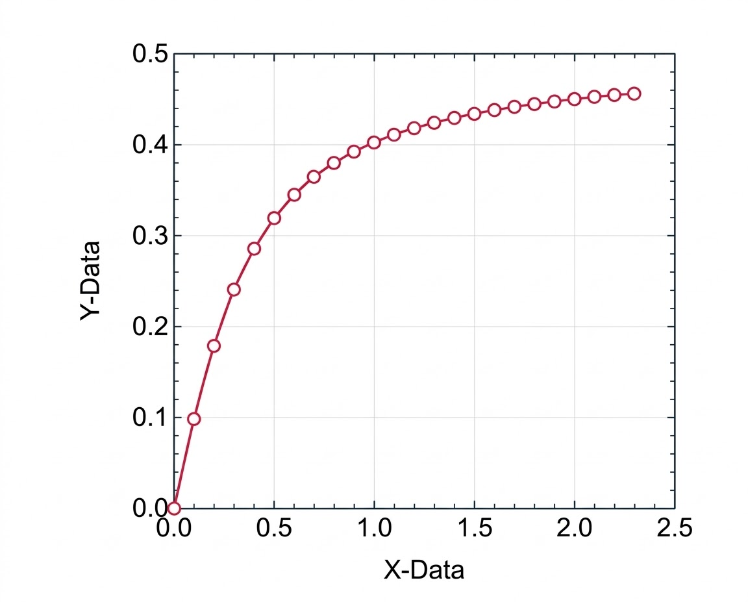

Figure 1. Plot of Y-Data as a function of X-Data.

References
[1] A.Author#1, A.Author#2, A.Author#3, et al., Journal, vol, page numbers (year).
[2] A.Author#1, A.Author#2, A.Author#3, et al., Journal, vol, page numbers (year).

